- All the tabs we need bigger size
- Log in to the pharmacist with name like first two letters from first name and aftername noaz and password

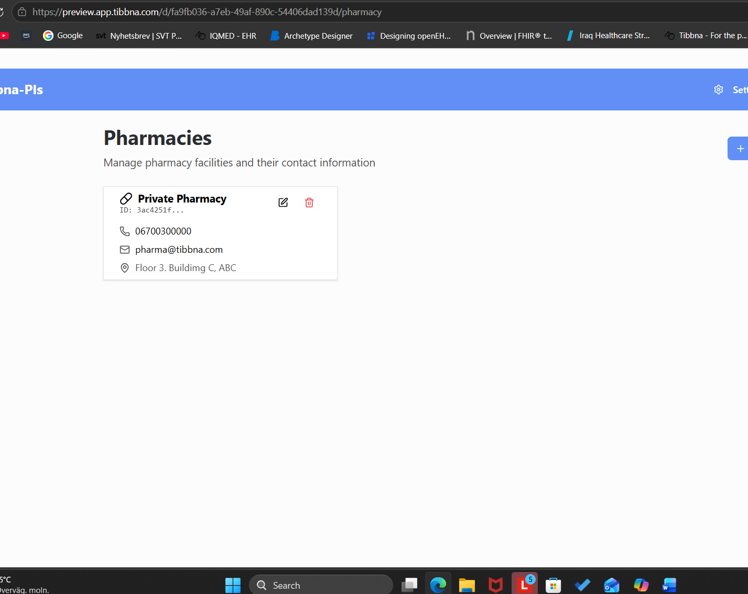

- we have to loose the problem how the pharmacist log in in the pharmacy system if another pharmacy have the same??

- dash board low stock medicine not necessary . we can have it in the inventory

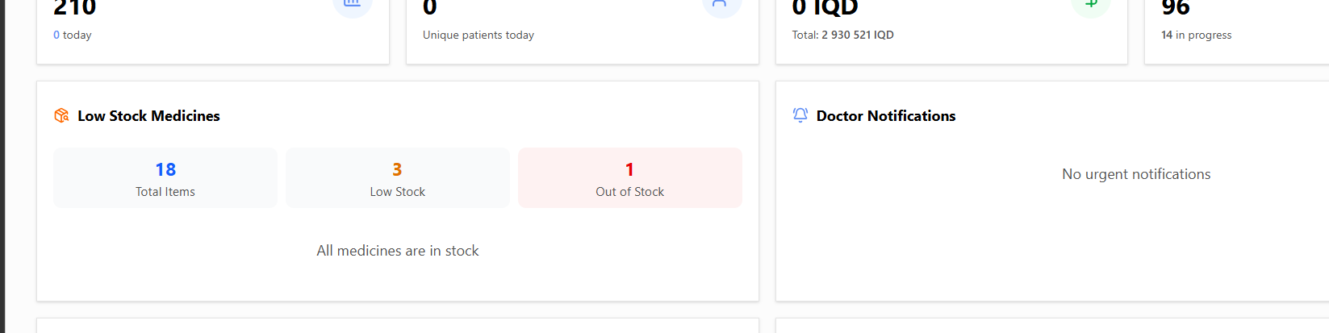

- order status! We don’t need it
- We need budget status like execl statistic * to account the budget daily . we can put it in the dashboard * suggestion

Order tab
- For new registration patient we need to add a next button that take to order and add drug order. NOT close the registration page and then go to order. It’s long process.
- Adding new patient is not showing in order search
- Add new prescriptions for existing patient the order now shows.
- When I write prescription or add it I can not find it after I have to write the name again /----
- We need dosage parcod label that is witten the dosage how to take the medicin daily
- Dosage instruction under the lm
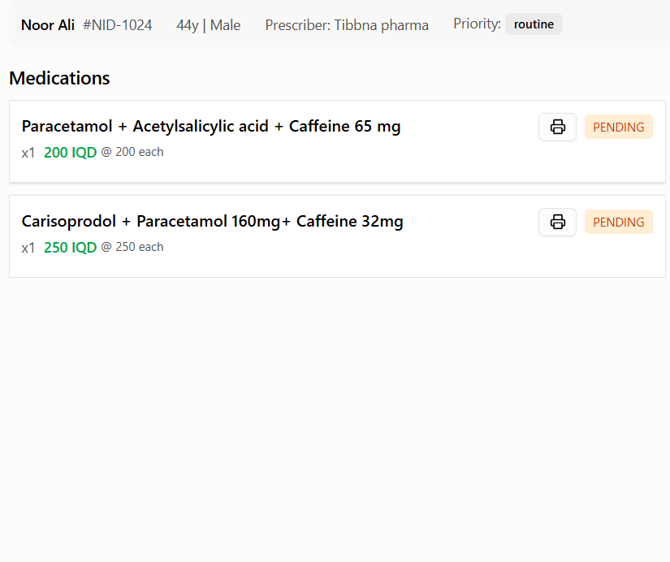

- Delete indication
- Dosage label * we need dosage instruction how to take the medicin * important. What the doctor write for dosage
- The payment in the right side please
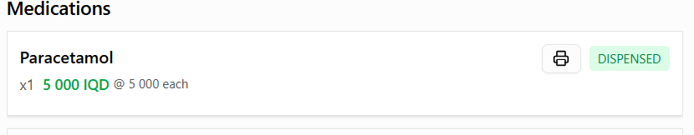

- When I press check out and I need to back again . its tooooo long process to back again to the patient order I need tab to back.
- Interaction > we can put it beside the medication . when wwe have a long list of medicin its gonna be much easier to see it the ((( another tab

Point of sale
- Search for what !

- We need to add percentage if we have medicin free
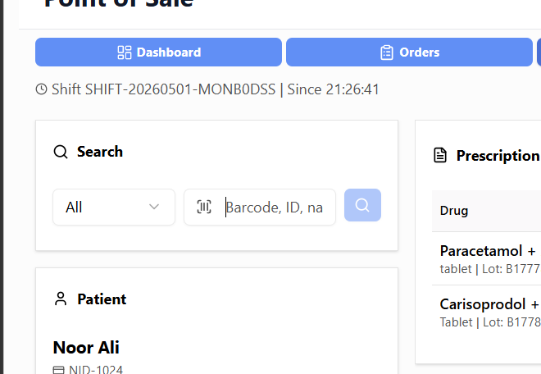

- I need tab back in sales of point
- Unite dos after drug name direct
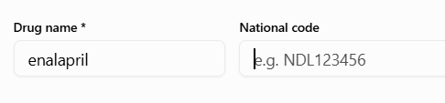

15 . put the name upper super prio 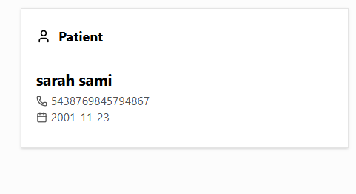
- We need to add date datum
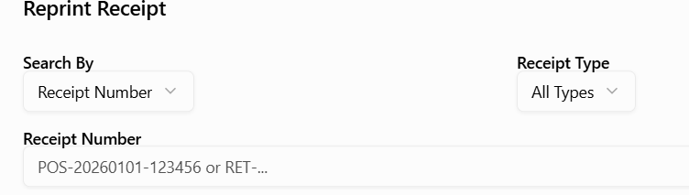

Drug registration

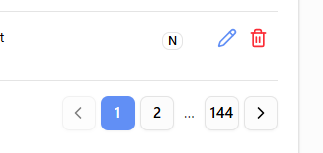

We need it up not down or just 20 rad

- We need a test return items !
- Remove to do we don’t need it ever

Instead of to do we can use reminder if we have a patient som take a medicin for long time so we can remind the patient we have your medicin you can come to take it.

